Metallic Bonding
Giant structures with free electrons
Metals form giant lattice structures of cations in which the valence electrons of the metal cations are delocalised -free to move throughout the lattice. The metallic bond is the force of attraction between these delocalised electrons and metal cations. Metallic bonds are strong, so metals can maintain a regular structure and usually have high melting and boiling points.
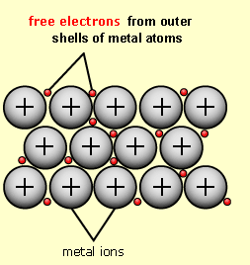
Metals are good conductors of electricity and of heat because the delocalised electrons easily respond to an electric field, or transfer heat energy through the metal. The free electrons allow metal atoms to slide over each other without actually breaking the bonds between the cations and the delocalised electrons, so metals are malleable and ductile.

